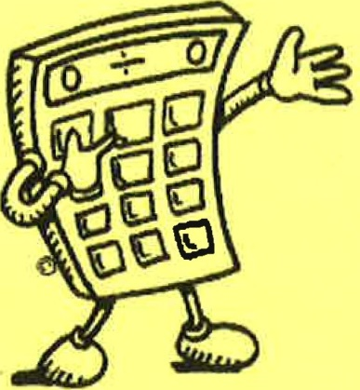
EXPENSE CALCULATOR

Complete the chart for your current expenses. If some of the expenses are deducted directly from your current pay
cheque, do not include them here. Some of those current pay-deducted expenses may be a direct cost to you in retirement so include them when completing the chart.

 |  | Current$ | In Retirement, as a couple | In Retirement, if single
HOUSING | Mortgage/Rent
 | Maintenance
 | Property Taxes
 | Insurance
 | Heating
 | Electricity
- | Telephone
- | CablejlV
 | Water/Sewer
 | Furnishing
 | Gardening
 | Other
TRANSPORTATION | Loan Payments
 | Gasoline
 | Insurance | -
 | License/Air Care
 | Maintenance
 | Other
HEALTH CARE | Life Insurance
 | Medical Premiums
 | Extended Medical
 | Dental Premiums
 | Travel Insurance | -
 | Drug Costs
 | Other
MISCELLANEOUS | Other
 | Other
 | Other
 | Other
TOTALS FOR THIS PAGE

 |  |  | Current$ | In Retirement, as a couple | In Retirement, if single
TOTALS FROM PAGE ONE
PERSONAL |  | Food at home
 |  | Food at work
 |  | Dining out
 |  | Clothing/Shoes
 |  | Dry Cleaning | -
 |  | Entertainment
 |  | Recreation
1::11;11 |  | Education/Books
 |  | Travel/Vacations |  | ::
 |  | Hobbies |  | ...:. | -
 |  | Gifts
 |  | Charitable Donations
 |  | Grooming, etc.
 |  | Pet Care
=:I |  | Other
= =
OTHER |  | Union/Prof. dues
 |  | Clubs etc. dues
 |  | Season's Tickets | =
 |  | Alimony/Child Supp. | ;;;;;;
 |  | Loan Payments·
 |  | Bank Fees
 |  | Other |  | -:::::::11
 |  |  |  | = | "'
SAVINGS |  | RRSP |  |  | =
 |  | RESP |  |  | ""
 |  | Investment
 |  | Emergency Fund
 |  | Education Fund
 |  | Tax Free Saving Act.
 |  | RRSP
 |  | Other
GRAND TOTAL

NET INCOME % | BUDGET CATEGORY | DETAILS OF CATEGORY
35% | Housing | Mortgage, Taxes, Strata  Rent  Insurance  Hydro
5% | Utilities | Phone, Cell Phone  Gas  Cable Internet
10 to 20% | Food | Grocery  Personal Care  Baby Needs
15 to 20% | Transportation | Bus Taxi Insurance, Maintenance, Parking
3 to 5% | Clothing | For all members of  Family
3 % | Medical | Premiums  Specialists  Over the Counter
5 to 10% | Personal and  Discretionary | Entertainment  Recreation  Tobacco, Alcohol  Eating Out  Gaming  Haircuts  Hobbies
5 to 10% | Savings | Plan to save money for expenses that don’t happen every month;  As well as your future, then you wlll have it when you need it
5 to 15% | Debt Payments | Many people find their budget is quite tight  Because their debt payents are closer to 25% of their income.

Develop your budget with the money you have available after government deductions from your pay cheque, but before voluntary deductions (e.g. RRSPs, pensions or other savings).

If you have expenses such as high debt payments, childcare, school expenses or giving, you will need to reduce your spending in other areas to accommodate these higher expenses.

