Re TIRE d
Shuswap District Retired Teachers Vol III No 1 January, 2017
________________________________________________________________________________________________________From The Prez:
In the last issue we noted that District 83 was inviting retired teachers to go on an “Emergency TTOC” list for callouts when the regular list is exhausted. Well, I had been hanging onto my certificate with the intention of perhaps teaching overseas after my last nestling departs. Once Patricia gave us encouragement (at the last brunch) I applied.
I can tell you that, at present, they really do need us; I have been working quite a bit. The situation could possibly be worse when a number of term-certain part time positions are filled this month. If you have been on the fence about this, it might be good to go on the list. Just be prepared for the impact it will have on your income tax situation.
Our next brunch, scheduled for February 16, 10 am, at the Podollan Inn, is intended to break up your mid-winter blues…please try to join us. We have invited a member of the RCMP to present the latest information about scams impacting seniors, so it should be quite an interesting event.
Leslie is working on kick starting the Shuswap Education History project. She is looking for people with photos and stories about the last 100 years of Shuswap education…if you can help out, please email or phone me. If you are interested in working on the project please contact myself or Leslie.
Larry Calvert, President
250-675-5395 or shuswaprtaprez@gmail.com

Christmas Brunch Featured Entertainment
Those who attended our Christmas Brunch were treated to music provided by Jim Johnson and caroling by Sue Ackerman’s Ukulele group. It made for a festive dining experience, and we thank them all for lending their Christmas cheer to the event! It even persuaded me to sing along…a major feat!!! Thank you all!

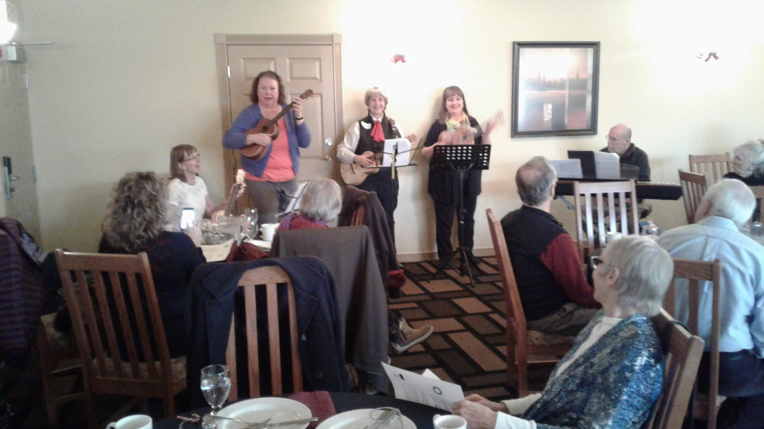

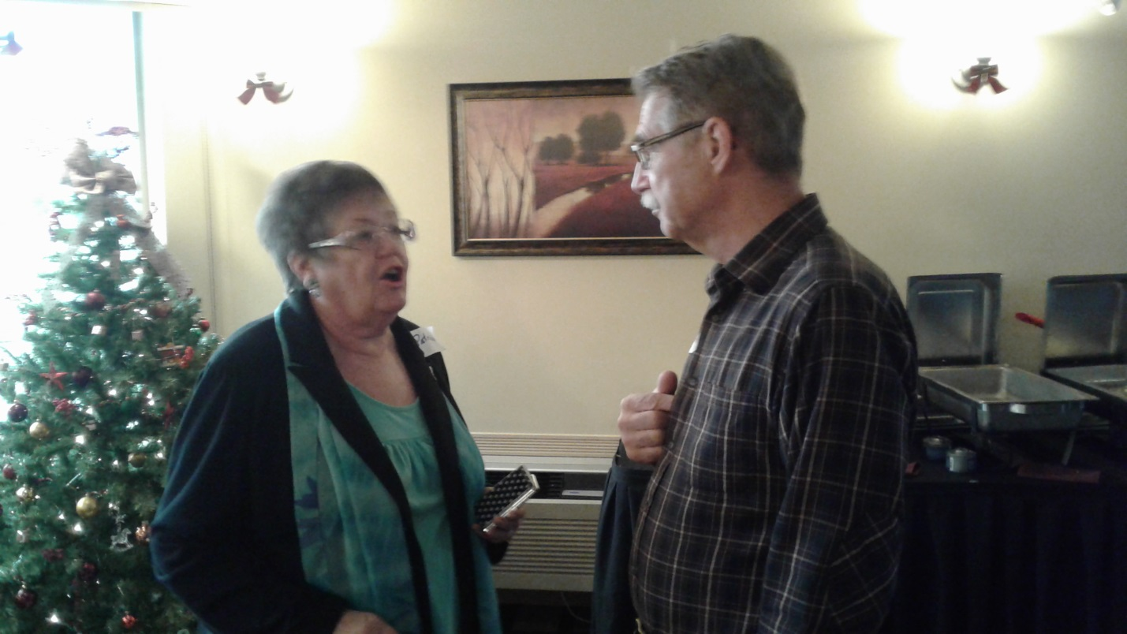
BCRTA President Patricia Clough was also present to pass along updated information to us.

BC Election Alert…2017 is the year!
This is our year to weigh in on how the provincial government has been treating us and our schools. Our executive has decided to hold another All Candidate Forum, in the wake of our successful forum before the Federal Election in 2015. We applied for – and have received -- $1200 from the BCRTA to stage the event, likely in late April. Anyone interested in assisting with planning and production is asked to contact me. We had a great turnout at the Seniors’ Center last time, and the thinking is to repeat the format for this event. We can only do it with your help, so please get involved and spread the word!

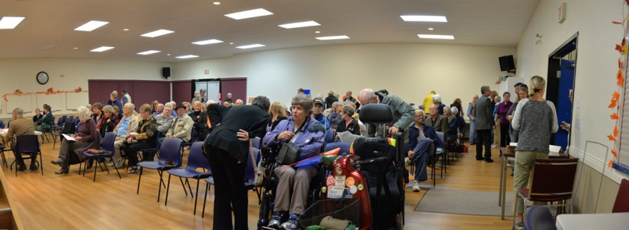
This was our crowd in 2015…let’s do it again!!!

REMEMBER:
Winter Breakout Brunch
Thursday Feb 16
10 am – dining 10:30 $15
Podollan Inn’s Table 24 Restaurant

We will ask for RSVPs shortly………………..

