Re TIRE d
Shuswap District Retired Teachers Vol IV No 1 March, 2018
________________________________________________________________________________________________________From The Prez:
My cousin is posting photos of spring flowers (albeit alongside her foundation on the sunny side) so it must be Spring! Even the calendar says so. Now we need the weather people to agree!

Anyway, on to more pressing thoughts. Kathleen Malone has been working hard to set up a COSCO workshop for our members, and has succeeded. We agreed that it would be good to include food with the workshop, so there will be a regular brunch service. The date will be Tuesday, April 10. Topic for the day is Wills and Estate Planning.

Here is the plan:
Doors Open (at Table 24) – 9:30 am
Food served -- 10 am
Speaker begins presenting – 11 am
Questions at 11:50 am
Event ends shortly after 12.

This is a bit of an experiment…combining a COSCO presenter with brunch…so we will be watching the numbers carefully. I will be asking for RSVPs next week, so please mark this on your calendar.
I hope to see you all there!

Larry Calvert, President
250-675-5395 or shuswaprtaprez@gmail.com

With SPRING will come TICKS…

This article is copied by permission of the Parksville-Qualicum RTA. It is very timely for us, as both people and ticks begin to emerge from winter hibernation…

Use THIS Simple Trick To Keep Ticks Off All Summer Long!
https://www.davidwolfe.com/trick-keep-ticks-off/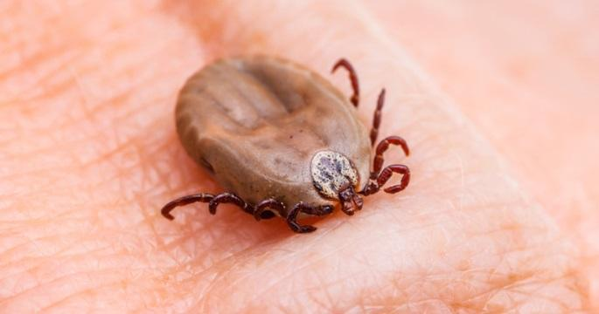

There’s nothing worse than coming home from a picnic, a hike or a fun day on the trails to find a tick burrowed in your skin.
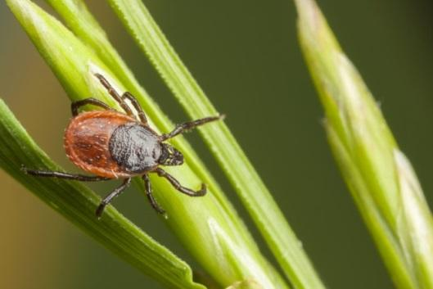
If you spend a lot of time outdoors, it’s important to know how to protect yourself from ticks. Not only are they pesky and uncomfortable, they can also carry deadly diseases that are extremely dangerous (Lyme and Powassan). The next time you’re enjoying nature, follow this simple trick to keep ticks from latching onto your skin!

Lint Roller and Essential Oil Tick Hack
All you need for this tick hack is a lint roller and some essential oils! Make sure your lint roller is the kind with adhesive layers. Simply take the roller with you when you’re going on a hike or doing yard work, and roll it on your clothing from time to time. After just a short time outside, you might be shocked to see what you pick up!

Adding some essential oil to this trick can minimize the risk of ticks hopping onto you as you work, bike or walk outside. Spraying essential oil onto your clothing and rubbing it onto your skin will help deter ticks from coming near you. This hack also works to deter mosquitoes and black flies. Using essential oils instead of tick or insect repellent helps to eliminate the amount of chemicals you’re exposed to.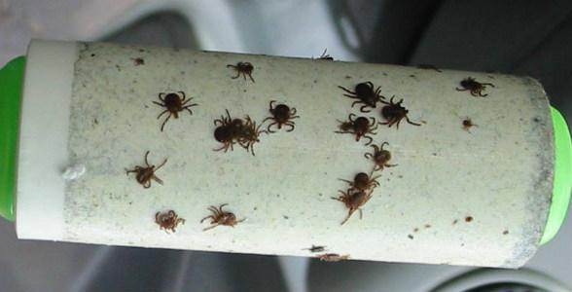

Here are the five best essential oils to help repel bugs:

Lavender – Lavender essential oils is a sweet smelling tick deterrent. You’ll love the smell, but bugs will hate it! It can help deter mosquitoes, flies and other unwanted insects.

Pennyroyal – Pennyroyal is a member of the mint family. This essential oil is toxic to insects which makes it an effective natural insect repellent!

Lemongrass – Lemongrass oil comes from the tropical lemongrass plant known as Cymbopogon citrates. It has a bright citrus scent and works as a natural flea and tick repellent. It can be sprayed directly on the skin to help ward off bugs.

Eucalyptus – Eucalyptus oil can be used alone or in combination with citronella oil for an all-purpose bug deterrent. A study published in the Journal of Medical Entomology found that eucalyptus extract has the ability to reduce tick bites and infections.

Lemon – Lemon essential oil contains a compound known as limolene. This compound is considered to be especially effective against fleas and other bugs. Use it in a diluted form, before spraying it onto your clothes or skin.

VIDEO (4 min.): Home-Made Non-Toxic Insect Repellent for Humans/Dogs/Cats
https://www.youtube.com/watch?v=ia9hkouPwj0

REMEMBER:

April 10 – Wills and Estates presentation at Table 24 (Podollan Inn)
Doors open 9:30, brunch at 10. $15 at the door

